|  |  |  |  |
| --- | --- | --- | --- |
| **PAPER CODE** | **EXAMINER** | **DEPARTMENT** | **TEL** |
| **CPT103** | **Jianjun Chen** | **Computer Science and Software Engineering** | **0512 81889137** |

**MOCK EXAMINATION 1**

**TIME ALLOWED: 2 Hours**

**INSTRUCTIONS TO CANDIDATES**

1. **This is a closed book examination.**
2. **Total marks available are 100.**
3. **Answer all questions.**
4. **Answer should be written in the answer booklet(s) provided.**
5. **Only English solutions are accepted.**
6. **The university approved calculator - Casio FS82ES/83ES can be used.**
7. **All materials must be returned to the exam supervisor upon completion of the exam. Failure to do so will be deemed academic misconduct and will be dealt with accordingly**.

**Question A: SQL**

Consider the following relations:

Company

|  |  |  |
| --- | --- | --- |
| cID | cName | Est |
| 1 | Apple | 1976 |
| 2 | Microsoft | 1975 |
| 3 | Oracle | 1977 |
| 4 | Kingsoft | 1988 |
| 5 | Redhat | 1993 |
| 6 | Nintendo | 1889 |
| 7 | Sun Microsystems | 1982 |

Product

|  |  |
| --- | --- |
| pName | cID |
| WPS | 4 |
| Office 365 | 2 |
| Apple II | 1 |
| Java | 3 |
| Switch | 6 |
| Java | 7 |
| Bug 10 | 2 |

1. You are given three SELECT queries. What are the results of application of these queries to the tables “Company” and “Product”? Provide the answer in a table format. In case that query is not valid, explain the reason.
   1. **SELECT** cName **FROM** Company **WHERE** Est > 1990
   2. **SELECT** * **FROM** Company, Product  
       **WHERE** Company.cID = Product.cID  
       **AND** (cName = ‘Apple’ **OR** pName = ‘Java’)
   3. **SELECT** * **FROM** Company  
       **WHERE** cID **NOT IN** (**SELECT** * **FROM** Product)
2. Write an SQL statement to find all companies that do not have their products listed. List company names only.
3. Write an SQL statement to find the number of products of each company. List company names and the number of products.
4. Write an SQL statement to list the product that is made by the oldest company.

Answers:

Q a.1

|  |
| --- |
| cName |
| Redhat |

Q a.2

|  |  |  |  |  |
| --- | --- | --- | --- | --- |
| cID | cName | Est | pName | cID |
| 1 | Apple | 1976 | Apple II | 1 |
| 3 | Oracle | 1977 | Java | 3 |
| 7 | Sun Microsystems | 1982 | Java | 7 |

Q a.3

In correct subquery. Should not return multiple column.

Q b

select c.cName

from company c

where cID not in (select cID from product p);

Q c

select c.cName, count(pName) as numProd

from company c, product p

where c.cID = p.cID

group by c.cID;

Q d

select pName

from company c, product p

where c.cID = p.cID and c.Est <= all(select Est from company);

**Question B: Functional Dependencies**

The relation below stores information about students, accommodation and academic advisers. Assume that more than one student may live in one room and each academic adviser advises a unique set of students. Electricity bills are applied to individual rooms.

|  |  |  |  |  |  |
| --- | --- | --- | --- | --- | --- |
| ElectricityBill | AdviserName | StudName | RoomNo | StudEmail | AdviserID |

From the given table data:

1. Identify the Primary Key for the relation.
2. Determine all functional dependencies.
3. From these dependencies, identify which are partial (if any) and which transitive (if any).

Answer:

1. StudEmail is the primary key.
2. Functional dependencies:
   1. StudEmail -> All other attributes
   2. RoomNo -> ElectricityBill
   3. AdviserID -> AdviserName
3. No partial dependency, Both 2 and 3 are transitive dependencies.

**Question C: Normalisation**

Normalise the following table “T” into the 3rd Normal Form by clearly describing the normalisation process, i.e. the dependencies removed and how the table is split into sub-tables. Describe the functional dependencies for each resulting sub-table.

|  |  |  |  |  |  |  |  |
| --- | --- | --- | --- | --- | --- | --- | --- |
| **A** | **B** | C | D | E | F | G | H |

Attributes (A, B) form the primary key. The relation has the following functional dependencies:

A, B -> C, D, E, F, G, H

B -> C

D -> E

E -> A

F -> G, H

Answer:

C is non-key attribute that is partially dependent on primary key.

To remove this partial dependency, we split the table into:

Table 1: [A, B, D, E, F, G, H] <- Indicate the primary key with underline here.

Table 2: [B, C]

E is transitively dependent on (A, B) via D.

To remove this transitive dependency, we split table 1 into:

Table 1-1: [A, B, D, F, G, H]

Table 1-2: [D, E]

G, H is transitively dependent on (A, B) via F.

To remove this transitive dependency, we split table 1-1 into:

Table 1-1-1: [A, B, D, F]

Table 1-1-2: [F, G, H]

The final database looks like:

Table 1-1-1: [A, B, D, F]

Table 1-1-2: [F, G, H]

Table 1-2: [D, E]

Table 2: [B, C]

**Question D: Entity-relationship Modelling**

You are hired by a port company to develop a database for managing container and yard data. In this port, containers are placed in different container stows (stow = container stacking area). Each stow has an identifier, a maximum number of containers supported. A stow has several slots for containers, each slot is associated with a slot id. Each container has its container identifier, current stow, current slot in the stow, weight and size. A container transport task involves transporting one or two containers from their initial position to a same target position. The target position is described using a target stow identifier and a target stow position.

Task 1: Draw the entity relationship diagram for the port company’s database.

Task 2: Based on your solution to Task 1 above, write the SQL code to create the tables for the database. You should include all the specified attributes and specify the appropriate primary and foreign keys. Minor syntactical errors in your SQL code will not be penalised in the marking of this answer.

Answer:

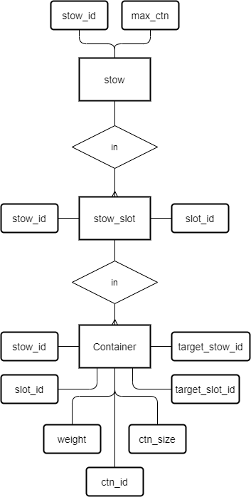

**create** **table** stow (

stow_id **int** **primary** **key**,

max_ctn **int**

);

**create** **table** stow_slot (

stow_id **int**,

slot_id **int**,

**constraint** stow_slot_pk **primary** **key** (stow_id, slot_id),

**constraint** stow_slot_fk **foreign** **key** (stow_id) **references** stow (stow_id)

);

**create** **table** container (

ctn_id **int** **primary** **key**,

stow_id **int**,

slot_id **int**,

weight **int**,

ctn_size **varchar**(20), -- can be int

target_stow_id **int**,

target_slot_id **int**,

**constraint** container_cur_pos_fk **foreign** **key**

(stow_id, slot_id) **references** stow_slot(stow_id, slot_id),

**constraint** container_tgt_pos_fk **foreign** **key**

(target_stow_id, target_slot_id) **references** stow_slot(stow_id, slot_id)

);

END OF RESIT EXAM